SNOWFLAKE
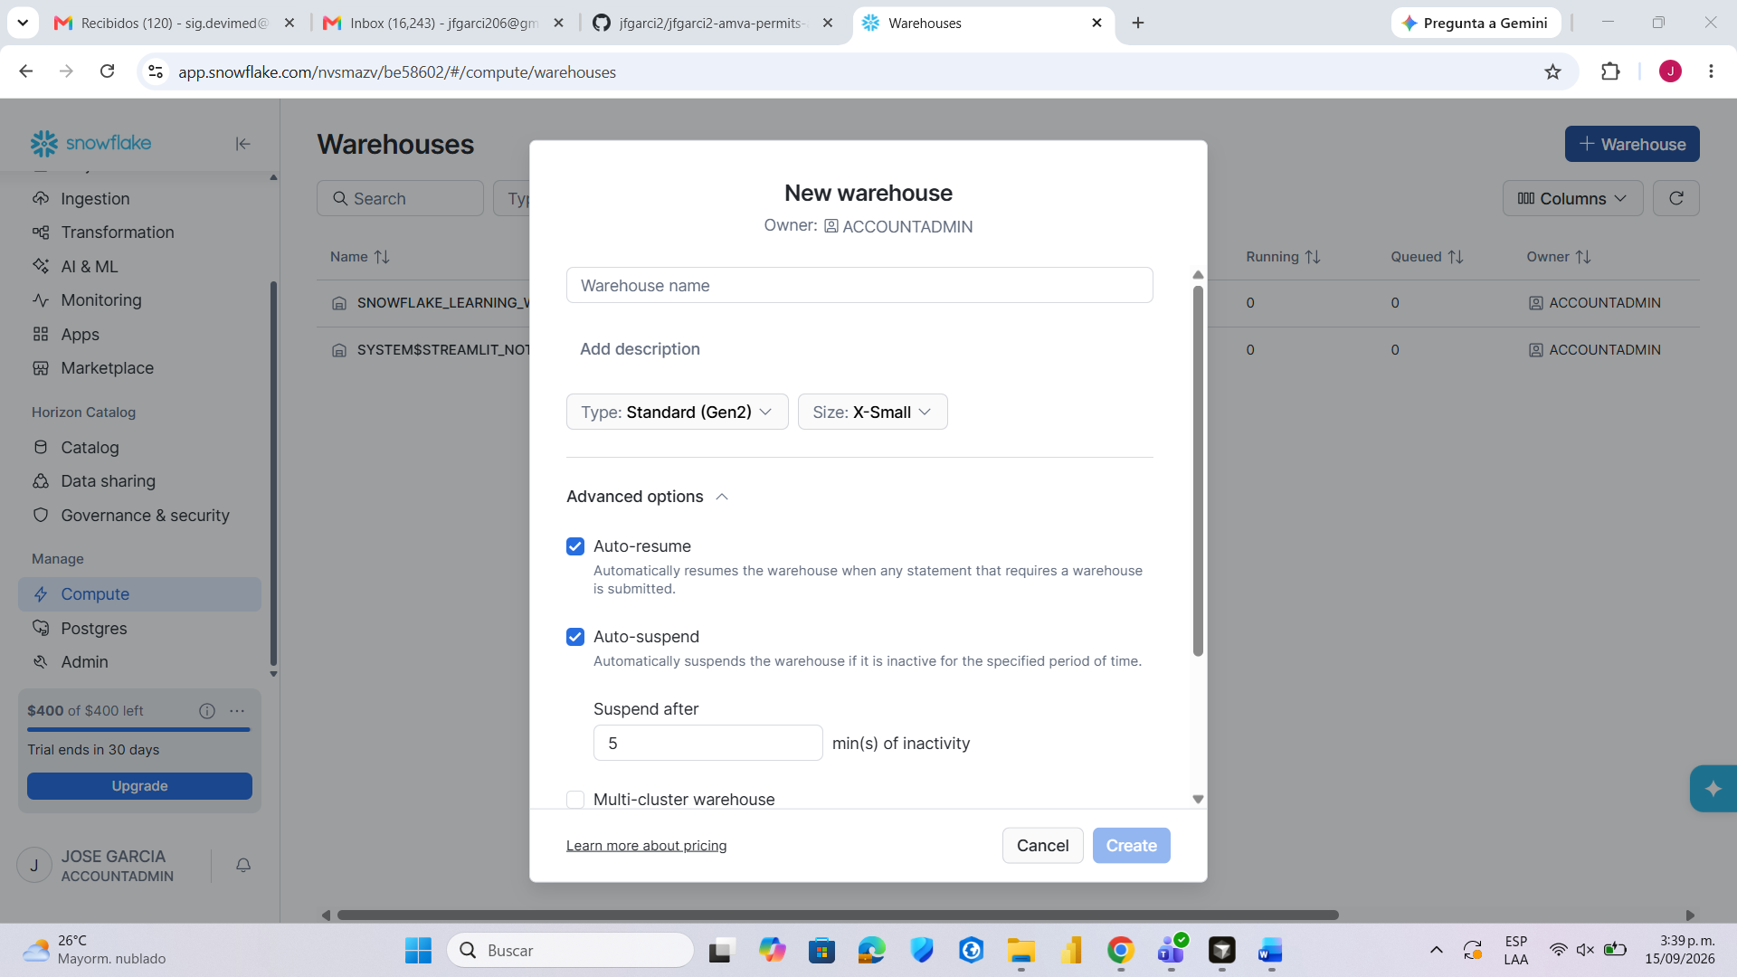
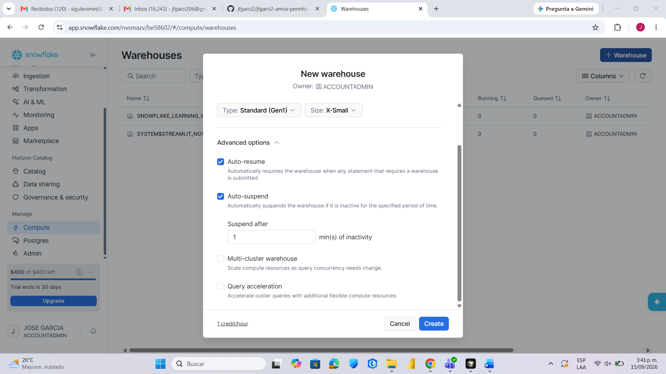
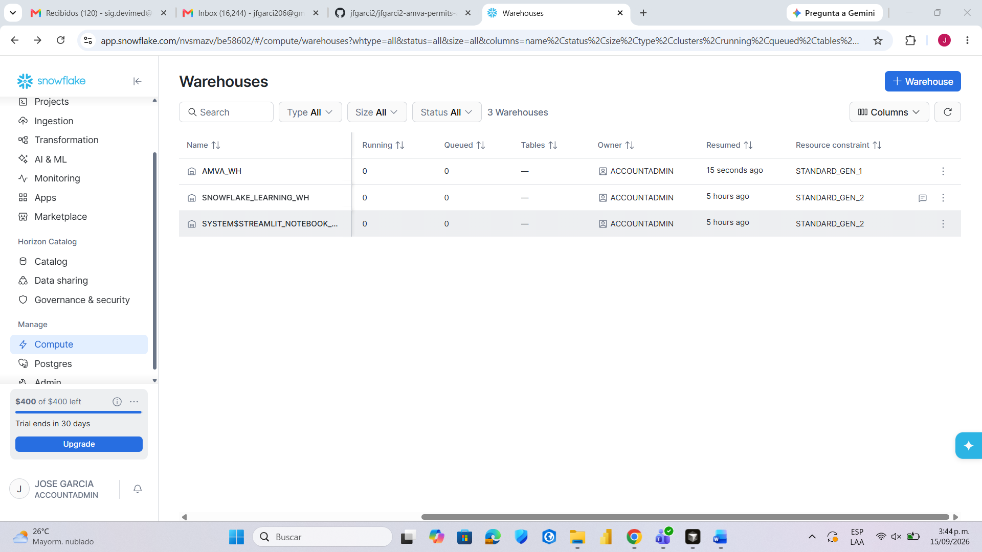
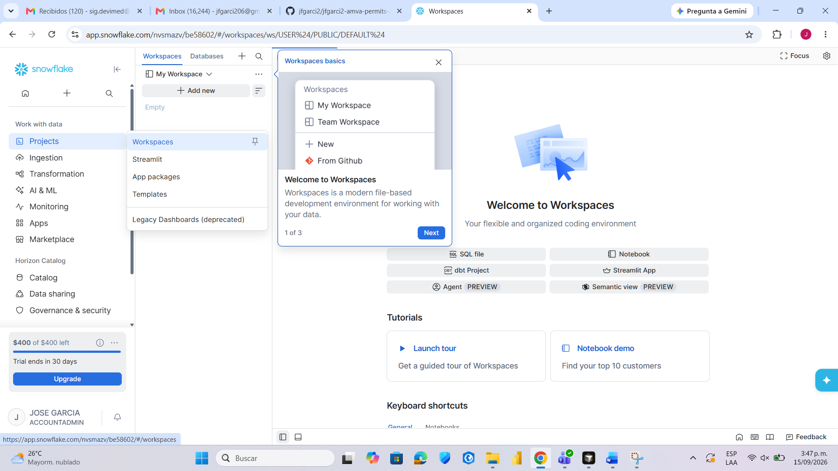
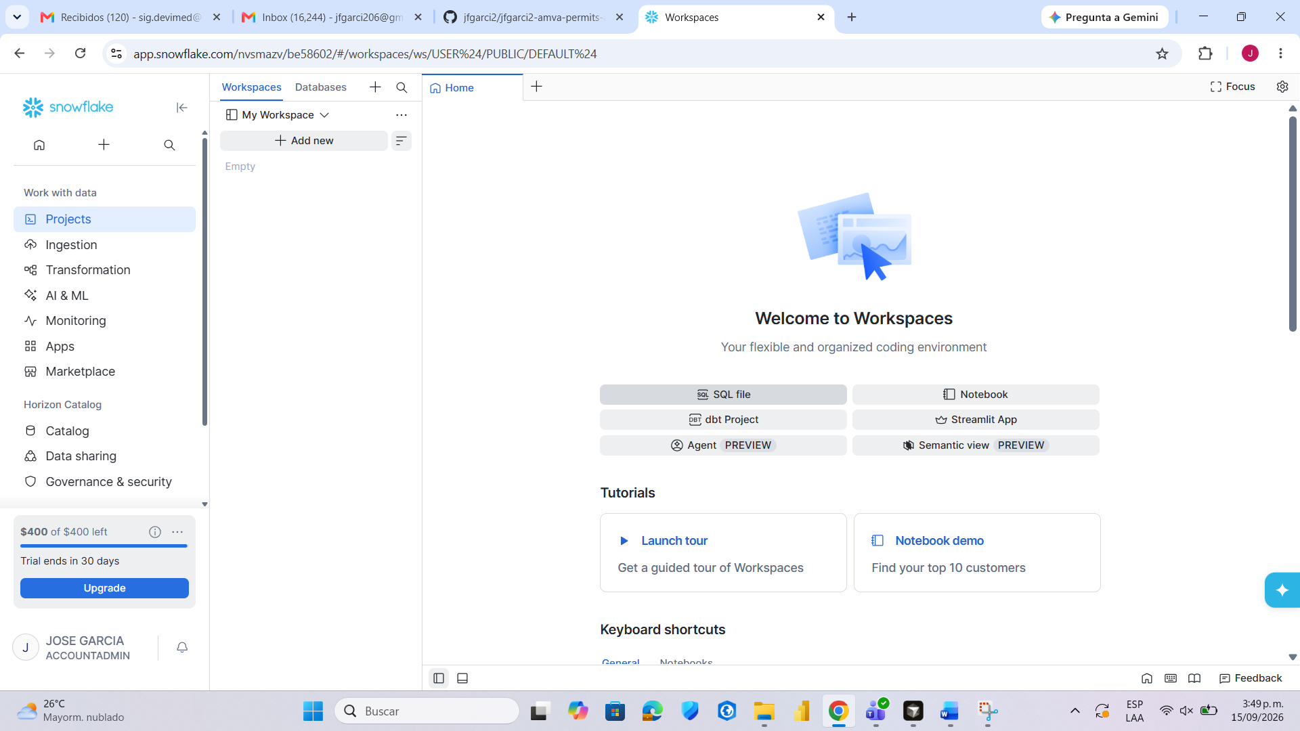
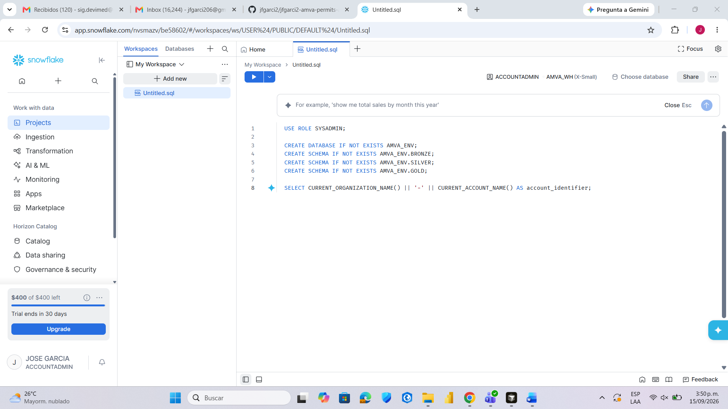
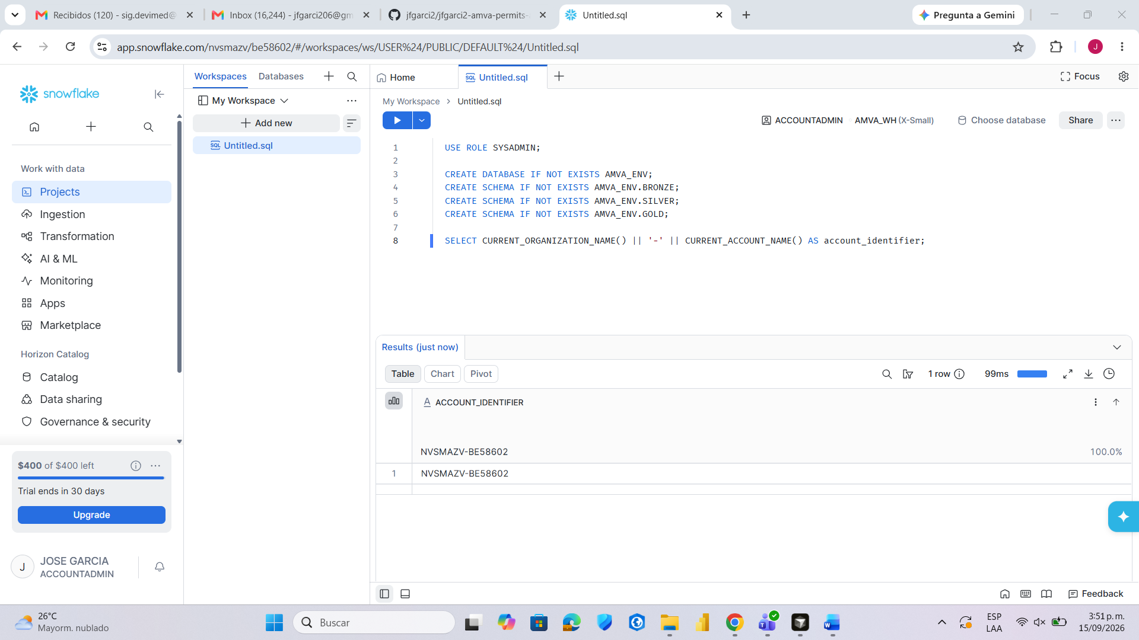

NVSMAZV-BE58602
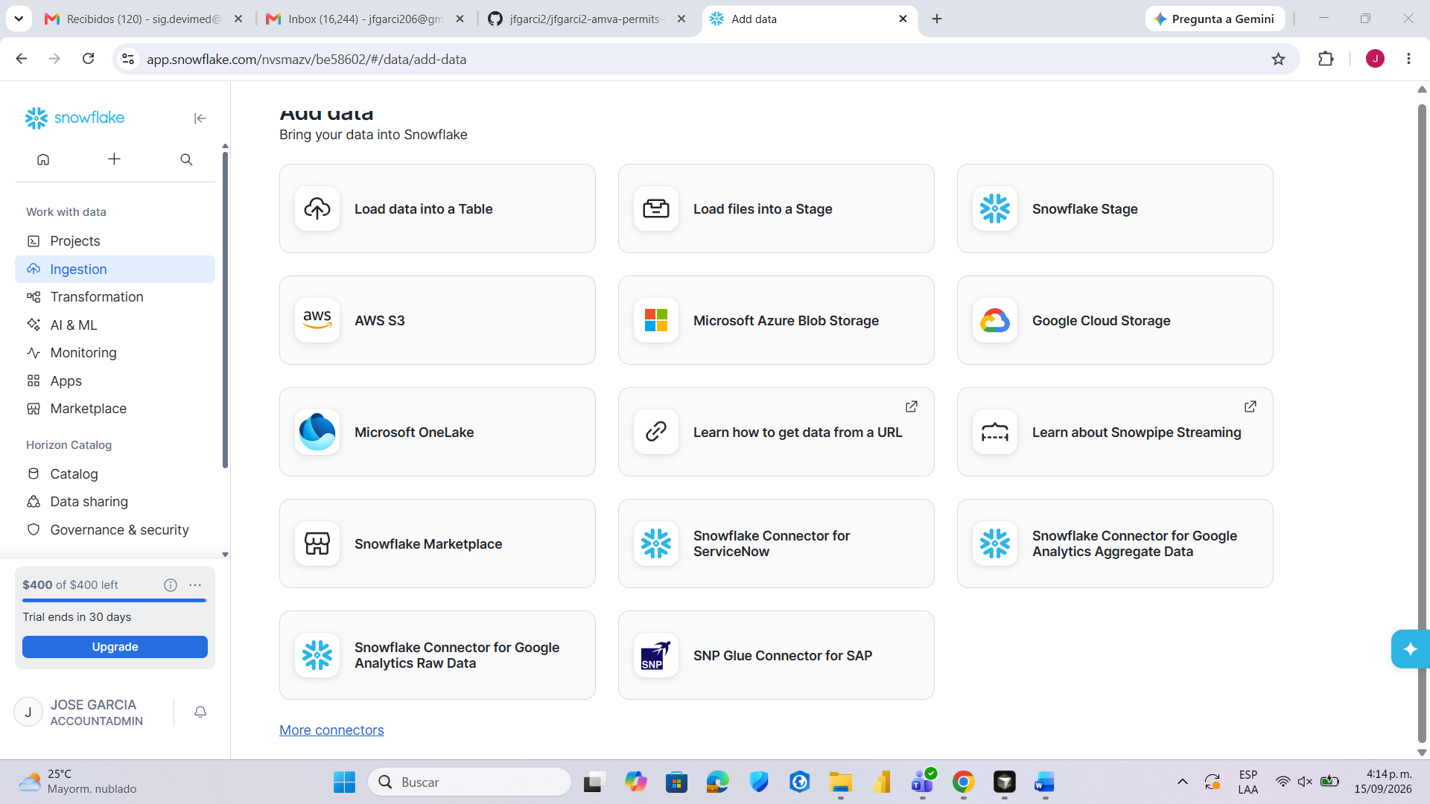
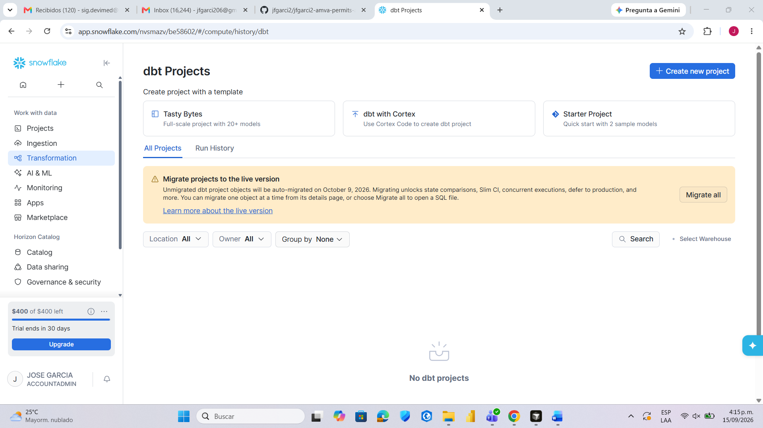

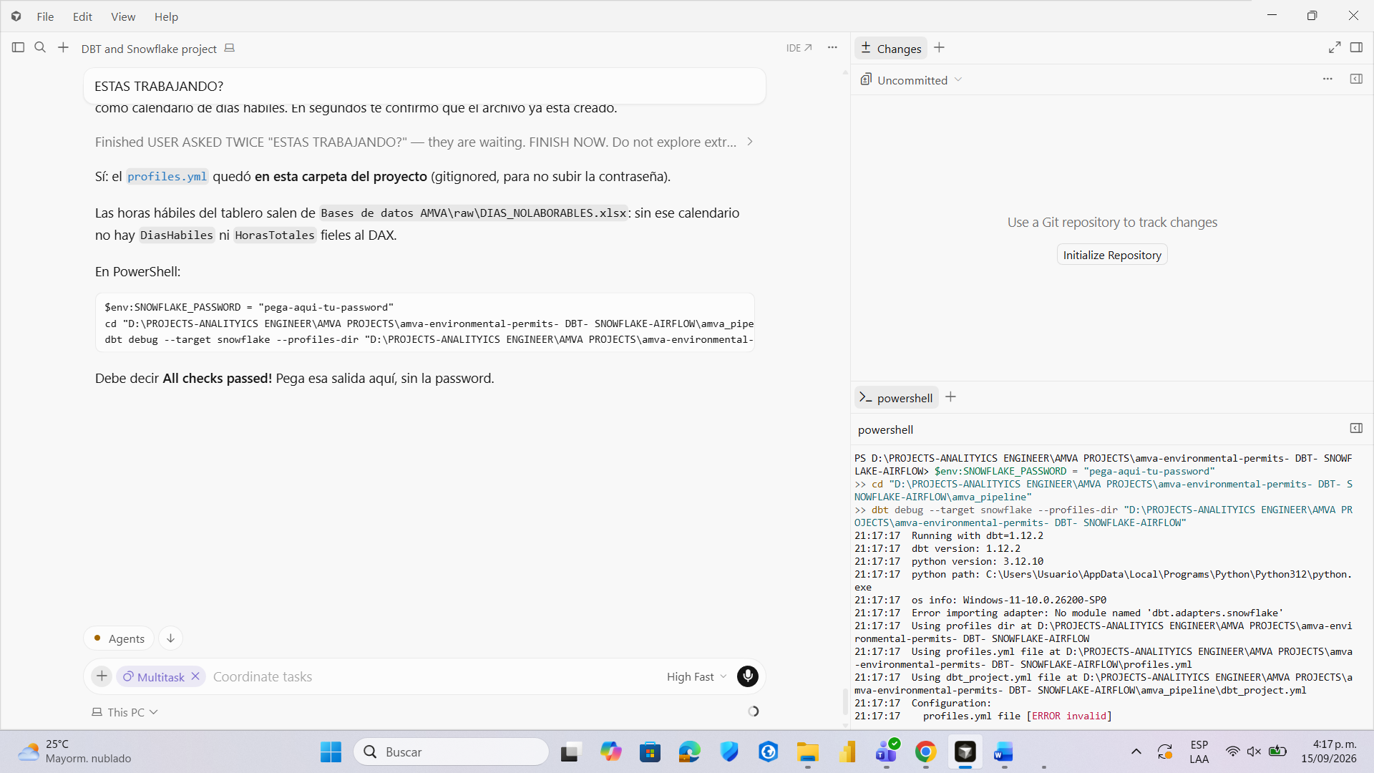
AHORA INSTALE ESTO PARA QUE PASARA
python -m pip install "dbt-snowflake>=1.9,<2.0"
dbt debug --target snowflake --profiles-dir "D:\PROJECTS-ANALITYICS ENGINEER\AMVA PROJECTS\amva-environmental-permits- DBT- SNOWFLAKE-AIRFLOW"
LUEGO
$env:SNOWFLAKE_PASSWORD = 'tu-password-de-snowsight'
cd "D:\PROJECTS-ANALITYICS ENGINEER\AMVA PROJECTS\amva-environmental-permits- DBT- SNOWFLAKE-AIRFLOW\amva_pipeline"
dbt debug --target snowflake --profiles-dir "D:\PROJECTS-ANALITYICS ENGINEER\AMVA PROJECTS\amva-environmental-permits- DBT- SNOWFLAKE-AIRFLOW"

